DATA SHEET

Product | COOLING SPRAY
Reference | 3153110
UDI-DI | 04262437040677
Visual | 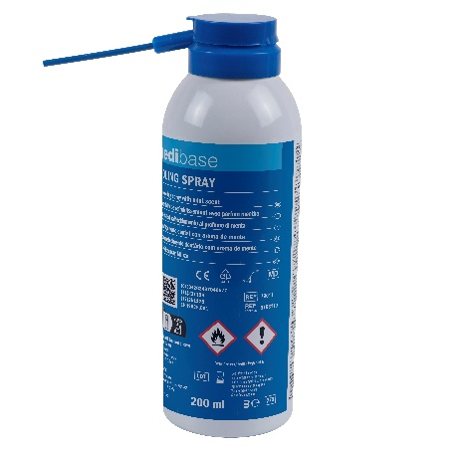
Description product | Cooling spray up to -45°C to be sprayed directly on the object to be cooled (e. g. impression pastes or foam balls)
Characteristics and composition | - Temperature of -45 ° C  - Minty taste  - Colorless  - Provided with an extension cannula for easy spraying  - Non-toxic (without chlorofluorocarbons)
Packaging | Cooling spray of 200ml
Shelf life | 2 years from the manufacturing date
Indications for use | Extremely flammable aerosol. Pressure vessel: may rupture under heat. Keep away from heat/hot surfaces/sparks/open flames/any other source of ignition. Do not smoke. Do not spray on an open flame or any other source of ignition. Do not puncture or burn, even after use. Protect from sunlight. Do not expose to temperatures above 50°C. Strongly cooled liquid gas. Contact with the product may cause cold burns or frostbite. Keep out of reach of children.  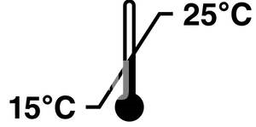
Legal information | Class I medical device under MDR 2017/745 regulation  CE Marking - Manufacturer: AERONOVA

Version 1.1 Made by SMA, date 03/07/2024

