
TECHNICAL SHEET

Designation | Mixing spatulas Medibase
Reference(s) | 3021027
Product picture | 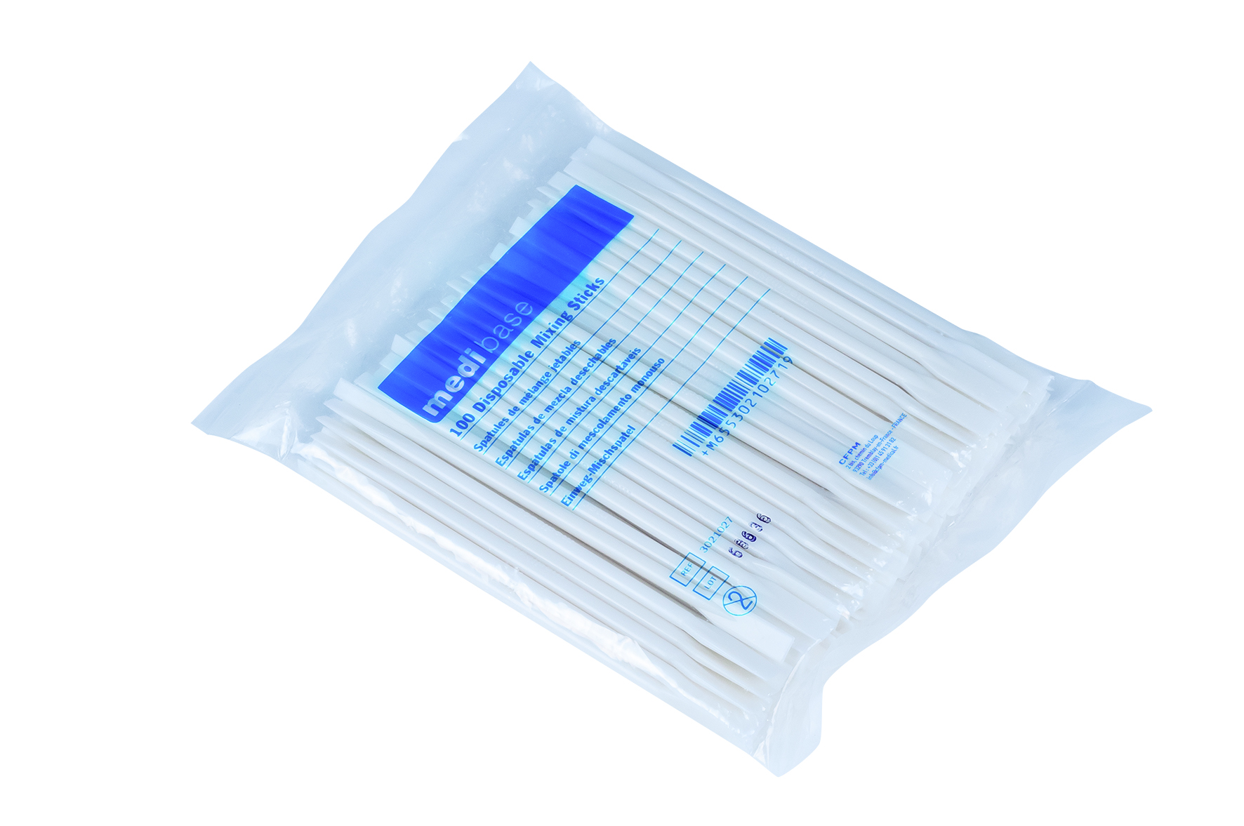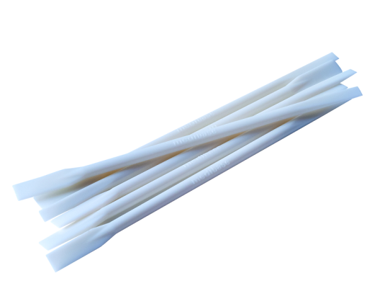
Product description | Double-ended mixing spatula in Acrylonitrile butadiene styrene (ABS)
Characteristics and compositon | - Aspect : Cylindrical hard plastic flat tip  - Color : White  - Length : 11.74 cm  - Diameter : 0.41 cm  - MEDIBASE logo embossed on each spatula
Packaging | Lot of 100 spatulas in plastic bag
Shelf life | N/A
Indications of use | 
Legal information | N/A
Version 2.2 Updated 15/11/2022 by RG

